**High Level Design (HLD)**

**Swiggy Data Analysis**

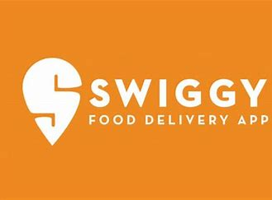

**Revision Number - 1.2**

**Last Date of Revision – 03/07/2022**

HIGH LEVEL DESIGN (HLD)

**Document Version Control**

|  |  |  |  |
| --- | --- | --- | --- |
| **Date Issued** | **Version** | **Description** | **Author** |
|  |  |  |  |
| 19/06/2022 | 1.0 | Abstract, | Shashank Nishad |
|  |  | Introduction, |  |
|  |  | General Description |  |
|  |  |  |  |
| 26/06/2022 | 1.1 | Design Detail, KPI, | Shashank Nishad |
|  |  | Deployment |  |
|  |  |  |  |
| 03/06/2022 | 1.2 | Final Revision | Shashank Nishad |
|  |  |  |  |

High Level Design (HLD)

**Contents**

Document Version Control.........................................................................................................2

Abstract......................................................................................................................................3

1 Introduction .............................................................................................................................5

1.1 Why this High-Level Design Document?.........................................................................5

1.2 Scope ...............................................................................................................................5

2 General Description ................................................................................................................6

2.1 Product Perspective & Problem Statement .....................................................................6

Housing prices are an important reflection of the economy, and housing price ranges are of

great interest for both buyers and sellers. In this project, house prices will be predicted given

explanatory variables that cover many aspects of residential houses..................................6

2.2 Tools used........................................................................................................................6

3 Design Details.........................................................................................................................7

3.1 Functional Architecture ....................................................................................................7

3.2 Optimization .....................................................................................................................8

4 KPIs.........................................................................................................................................9

4.1 KPIs (Key Performance Indicators) .................................................................................9

5 Deployment.............................................................................................................................9

**Abstract**

Working as a bridge between restaurants and customers, Swiggy utilizes an innovative technology platform that works as a single point of contact. Their app allows urban foodies to order food from nearby restaurants and get it delivered at their doorstep. Customer Segments of Swiggy The customer segments of Swiggy include those people who do not wish to go out to restaurants and eateries to buy food. People who want to order food online and want to get it delivered at their doorsteps are the principal customers of Swiggy

**1 Introduction**

**1.1 Why this High-Level Design Document?**

The purpose of this High-Level Design (HLD) Document is to add the necessary detail to the current project description to represent a suitable model for coding. This document is also intended to help detect contradictions before coding and can be used as a reference manual for how the modules interact at a high level.

**The HLD will:**

* Present all of the design aspects and define them in detail
* Describe the user interface being implemented
* Describe the hardware and software interfaces
* Describe the performance requirements
* Include design features and the architecture of the project
* List and describe the non-functional attributes like:

-Security

-Reliability

-Maintainability

-Portability

-Reusability

-Application compatibility

-Resource utilization

-Serviceability

**1.2 Scope**

The HLD documentation presents the structure of the system, such as the database architecture, application architecture (layers), application flow (Navigation), and technology architecture. The HLD uses non-technical to mildly-technical terms which should be understandable to the administrators of the system.

**2 General Description**

2.1 Product Perspective & Problem Statement

This is one of the major challenges faced by swiggy. Often it happens that restaurants fail in developing a second or alternative line of operations to deal with online delivery orders. Unreliability in Delivery & Logistics Staff.

The objective of the project is to perform data visualization techniques to understand the insight of the data. This project aims apply various Business Intelligence tools such as Tableau or Power BI to get a visual understanding of the data.

**2.2 Tools used**

**Importance of Business Intelligence tools**

1. Gain insight into customer behaviour. It boosts your ability to analyze the customer buying trend.
2. To make data useful. If you know how to use a BI tool, you won’t have to skim through hundreds and hoards of pages.
3. Increases Sales or Marketing Intelligence. Whether you are a salesperson or a marketing person, you would probably like to keep a track of customers.
4. To increase Efficiency. Such a system can improve efficiency within the organization and as a result, increases productivity.

 

  

**3 Design Details**

**3.1 Functional Architecture**

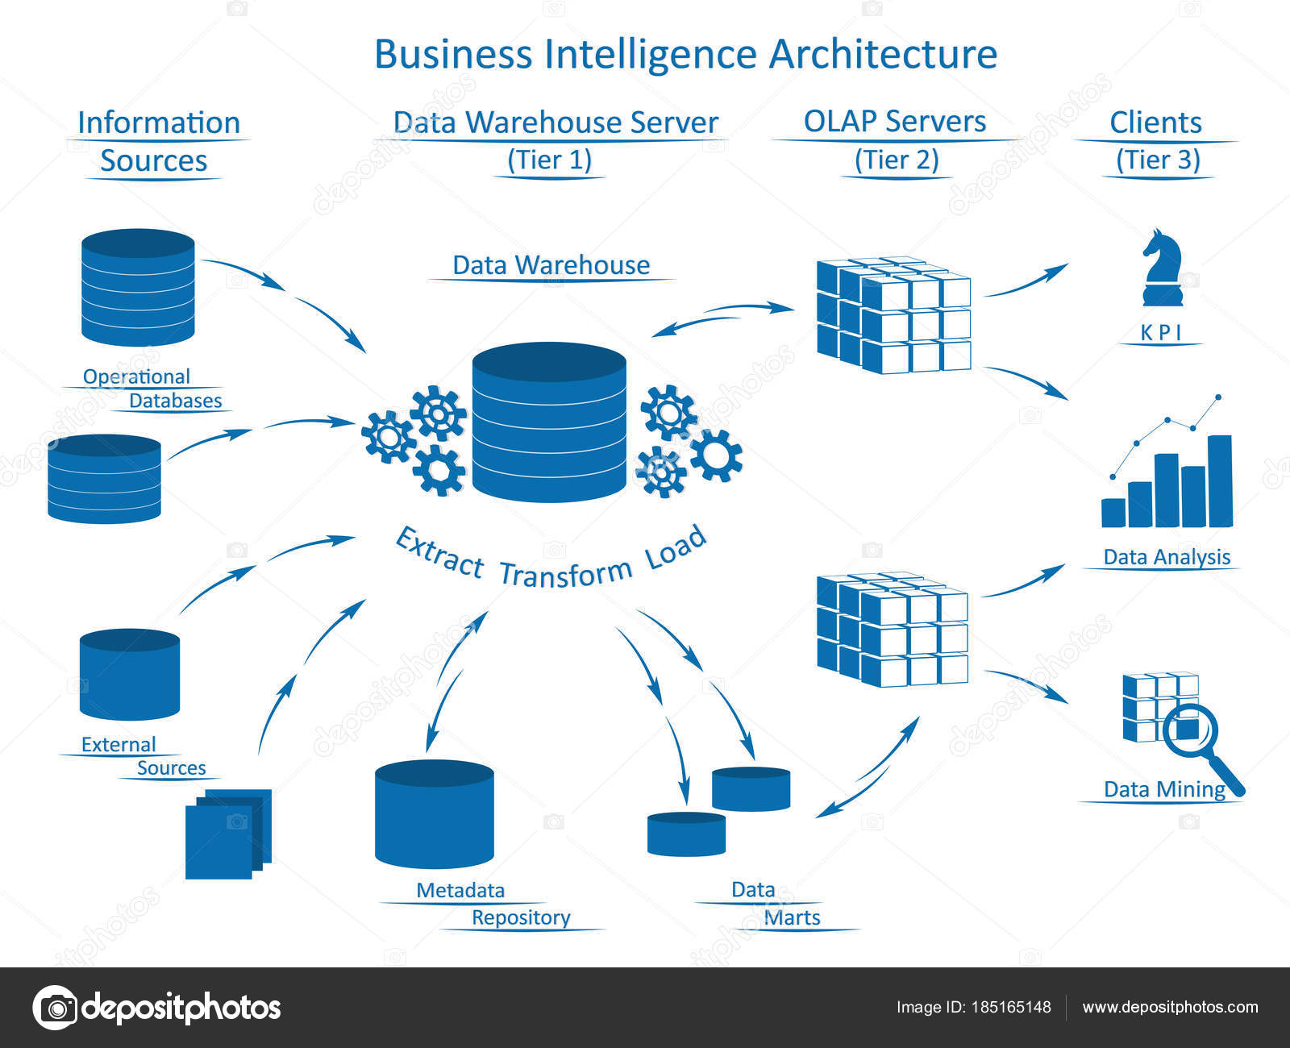

**HOW BI REALLY WORKS**

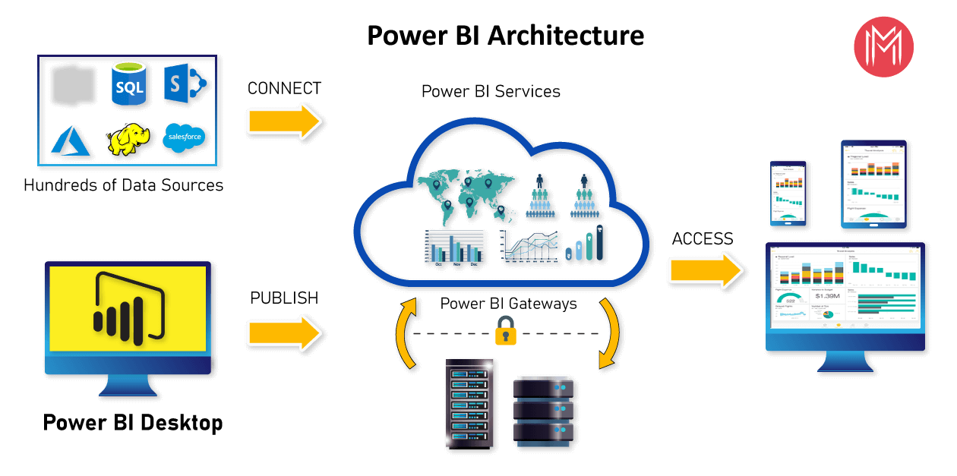

**3.2 Optimization**

Swiggy generate terabytes of data every week and leverage this data for delivery efficiency and to connect customers to the right restaurant. With our expansion across cities, our order volume has also grown over 200%. We have gone from being an app that would just get the job done to an app that delights the user every time they come to place an order. Real-time, micro-optimization of dynamic demand-supply, done millions of times every day.

* Logistic Optimization: Optimizing the cost of delivery while ensuring that customers get their product within the promised delivery times. This involves a combination of ML based models and a mathematical multi-objective function for optimizing across multiple business and customer experience constraints.
* Greater Personalisation: Aided by machine learning, the app personalizes the list of restaurants that users can view, based on their past orders, searches, and interactions with the app. This reduces the time to arrive at the choice of restaurants and dishes by half
* Faster Reordering: “Repeat” tags for preferred restaurants and dishes, and a complete order history helps users reorder their favourites with just a tap
* Simpler Order Tracking: Live order tracking is one of the most loved features of the Swiggy app. The app shares the expected time of arrival (ETA) of the order in real-time
* Smart Kitchen: Optimizing in-kitchen operations through AI driven initiatives such as forecasting demand, inventory optimization, dynamic order prioritization, intelligent kitchen capacity management, food quality management through computer vision and more.

**KPI AND DEPLOYMENT 4 KPI**

Dashboards will be implemented to display and indicate certain KPIs and relevant indicators for the disease.



As and when the system starts to capture the historical/periodic data for a user, the dashboards will be included to display charts over time with progress on various indicators or factors

**4.1 KPIs (Key Performance Indicators)**

Key indicators displaying a summary of the Heart Disease Analysis and its relationship with different metrics

1. Percentage of People Having Online Order for the Geographical Area.
2. Number Of Item Sold In Three Year.
3. Average Number Day Of Delivery.
4. Which item most sold its depend upon the number of quantity.
5. Total number of sale.

**5 Deployment**

Power BI prioritizes choice in flexibility to fit, rather than dictate, your enterprise architecture. Power BI Desktop and Power BI Service leverage your existing technology investments and integrate them into your IT infrastructure to provide a self-service, modern analytics platform for your users. With on-premises, cloud, and hosted options, there is a version of Power BI to match your requirements.

The Dashboard is published on Power BI service and an auto-refresh mode has been set so that the dashboard keeps on updating as the real time data loads into the log file.

The Dashboard showcases the multiple insights that has been drawn from the log files as follows:

1. **Summary:** The dashboard contains the statistical summary of the dataset and the visual displaying the effect of different feature to swiggy food industry.
2. **Critical Factors:** This swiggy Bangalore outlate data show there are purchasing power of a customer for a particular location and particular product is low so the standard deviation graph decrease the mean.